**Personal Portfolio 2**

Zubair Siregar (n9142614), Team 94

Artefact 1. Simple Menu for Property Agents

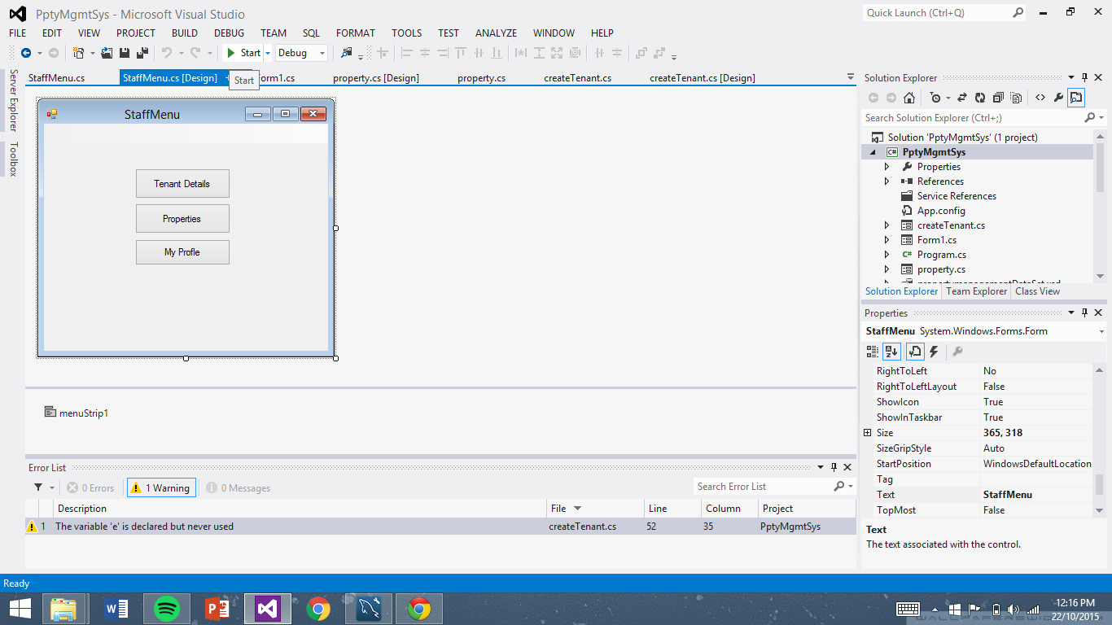

Instead of using a menu strip at the top, I decided to use buttons to link in to different forms.

Artefact 2. (Continue from Release 1) Enabling Delete function for Tenant Records

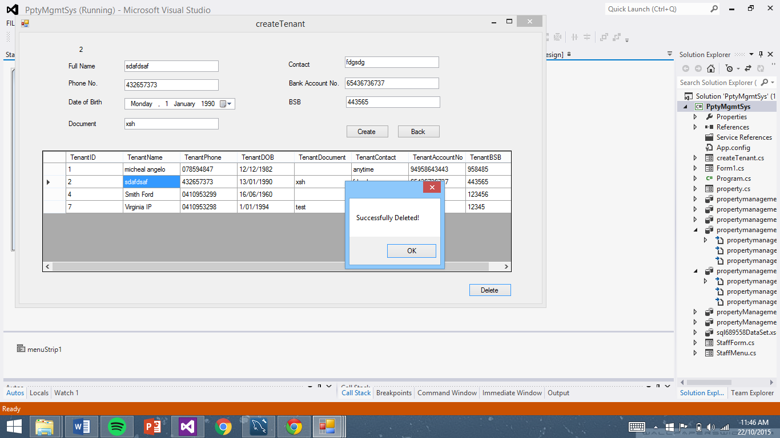

Artefact 3. Viewing of Properties for Agents

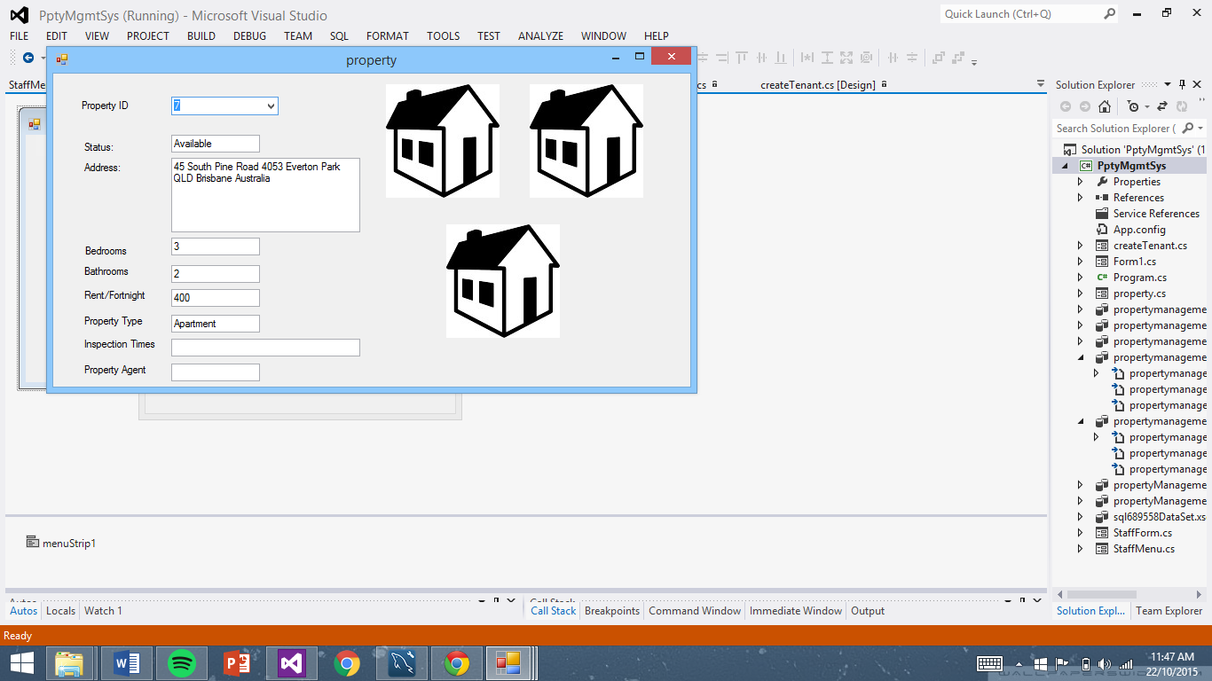

Artefact 4. C# Code for Deleting tenant record

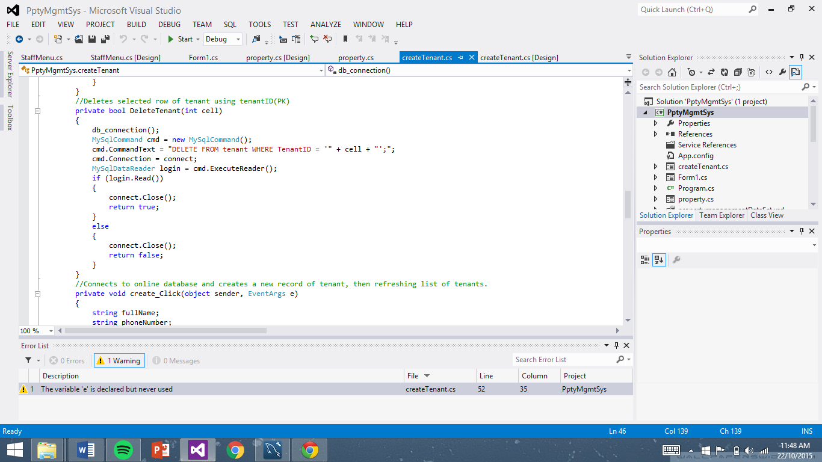

Artefact 5. C# code for retrieving data from database onto application

